**HR EMPLOYEE ANALYSIS**

**Problem statement:**

The Synthetic Employee Records Dataset is a simulated dataset created to explore various data analysis and machine learning techniques in the context of human resources and employee management.

**Methodology**:

**Data Collection**: Gather historical and current HR data (e.g., employee performance,

Recruitment data, engagement scores).

**Data Analysis**: Use statistical models and machine learning algorithms to identify patterns and relationships in the data.

**Prediction Models**: Develop models to predict future events or outcomes, such as employee turnover, performance, or hiring needs.

**DATA SOURCE LINK**:

<https://www.kaggle.com/datasets/ravindrasinghrana/employeedataset?select=employee_engagement_survey_data.csv>

**Features:**

Excel dash board development. The processed data is conveying the four to single file and the create the files to data cleaning and data transformation.

The data cleaning process in excel put in the data to remove duplicates and remove errors. Again, the data replace and find the irrelevant contents and irregular data to modify this process.

The transformation process is using the particular formulas to transform the data in our visualization process based makes in the dataset dash boards.

Dashboard Development in Power BI The processed data is imported into Power BI, where interactive visualizations are created.

Calculated measures and columns are defined using DAX (Data Analysis Expressions) to compute key metrics, including attrition rate, average salary, and years of service.

Data modelling establishes relationships between different employee attributes, allowing for better segmentation and filtering.

**Table of Contents**

**1. Excel Analysis:**

1.1. Data formatting & Cleaning

Data formatting.

Remove Duplicates.

Replace values.

**Handle Null / Invalid Value.**

Text Clean-up.

Standardize Date & currency Columns.

**2. Data Transformation:**

2.1. Data Transforming and conditions

Concatenate / Combine columns.

Change Full Names.

**Conditional Transformation.**

**Proper Conditions from Phone Number and Address.**

**Find AGE.**

**Find experience.**

Removed Unwanted Columns.

**3.Data modelling:**

Find measures.

Calculate Function.

Final view.

**4. Visualization:**

HR Employee analysis dashboard.

Applicant analysis dashboard.

**EXCEL ANALYSIS**

**Data Transformation & Cleaning**:

Excel Tables are handy containers for your data. They ensure that the values in a row stay together, which prevents you from accidentally scrambling the data when you sort and filter columns.

To make a table, click on any cell, then go to Insert > Table and select the range. Or use CTRL + T as a shortcut.

In Excel Tables, each column has a sortable filter included in its header.

**Data formatting:**

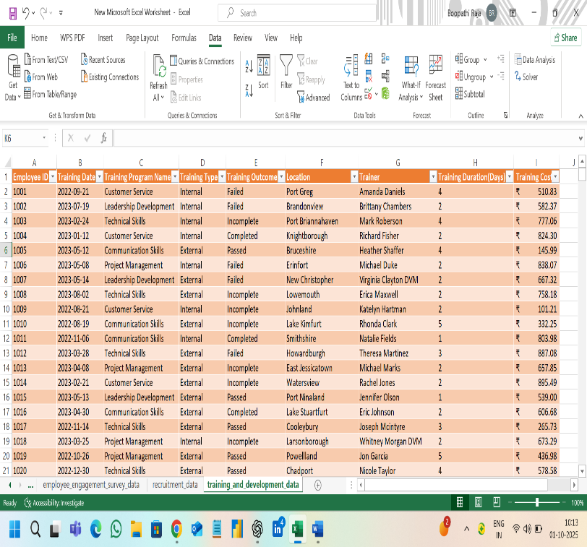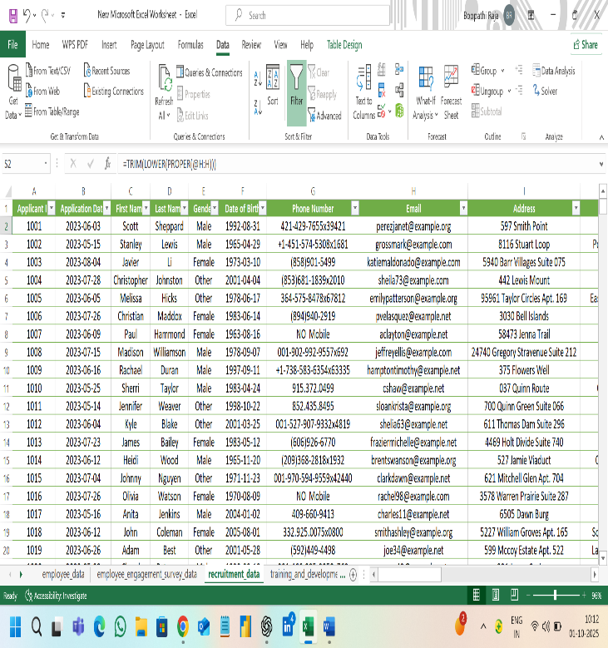

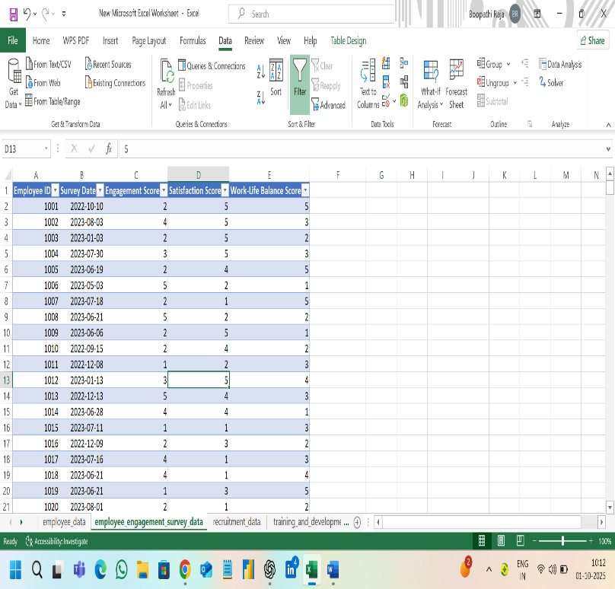

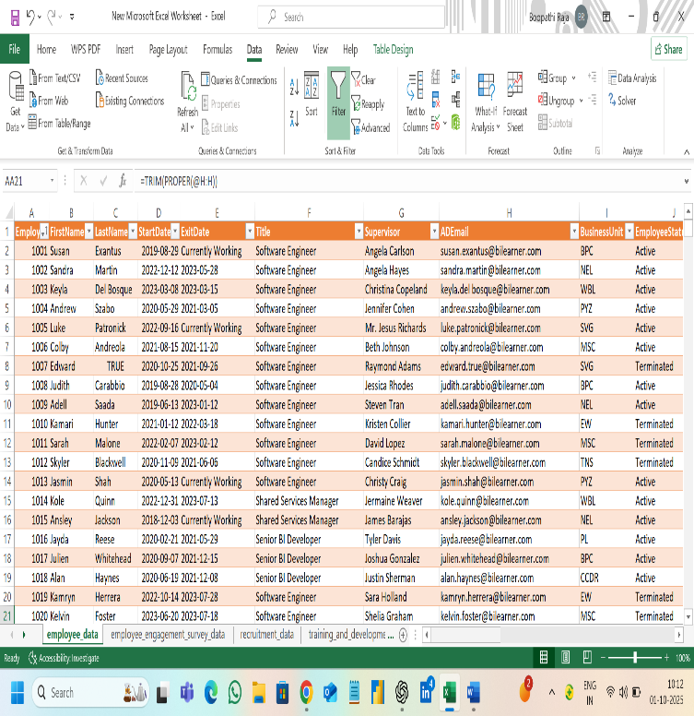

**Remove duplicates:**

If you are working with Excel Tables, the Table Design tab contains a ‘Remove Duplicates’ button. It removes any rows that contain duplicate values on the selected columns.

Fortunately, there are no duplicate rows in our dataset.

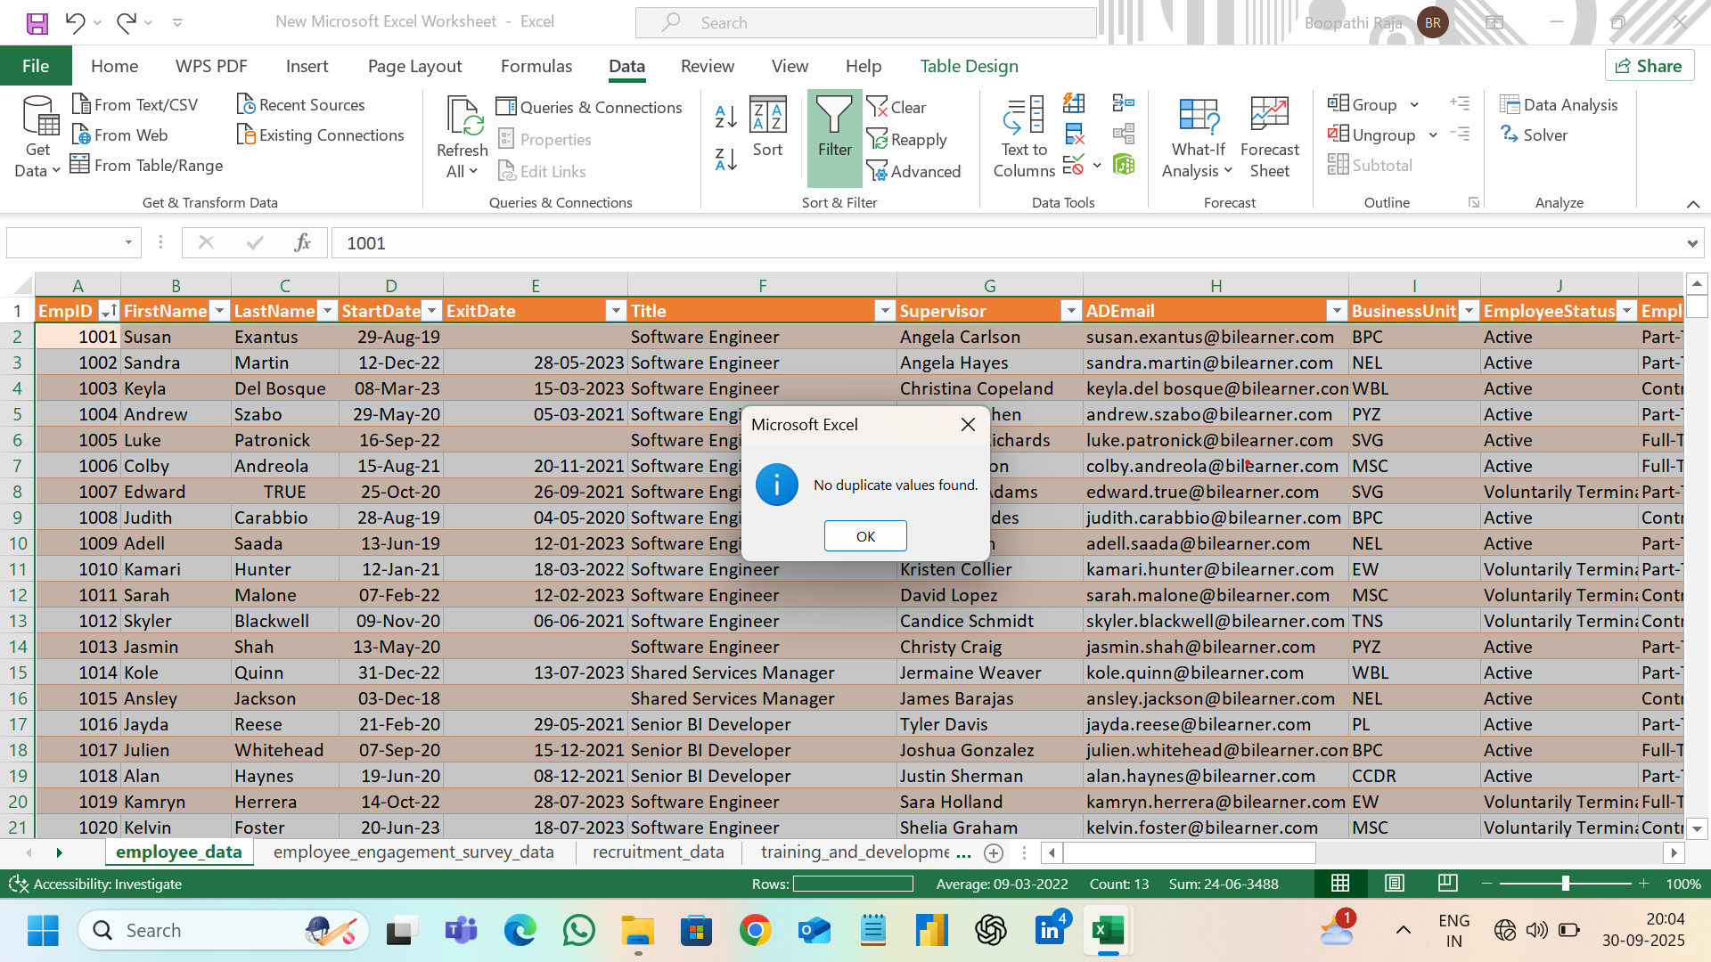

**Replace values:**

The VALUE function helps convert numbers stored as text to actual numeric data. Note that Excel, by default, aligns text strings to the left. Numeric data is default right-aligned. This gives you a visual clue as to how Excel interprets your data.

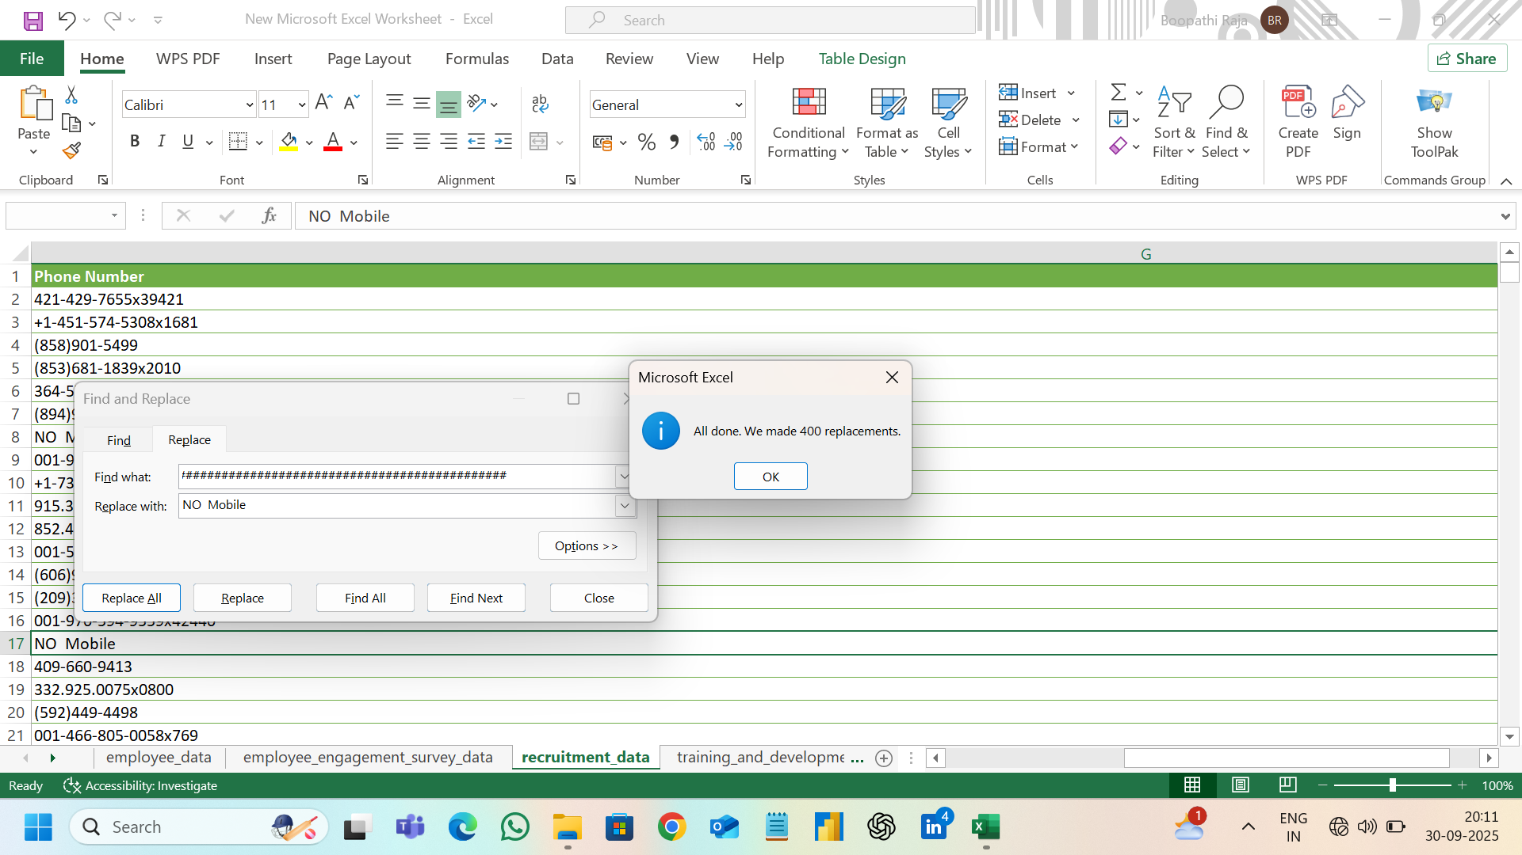

Replace values currently values to today (=today ()) function.

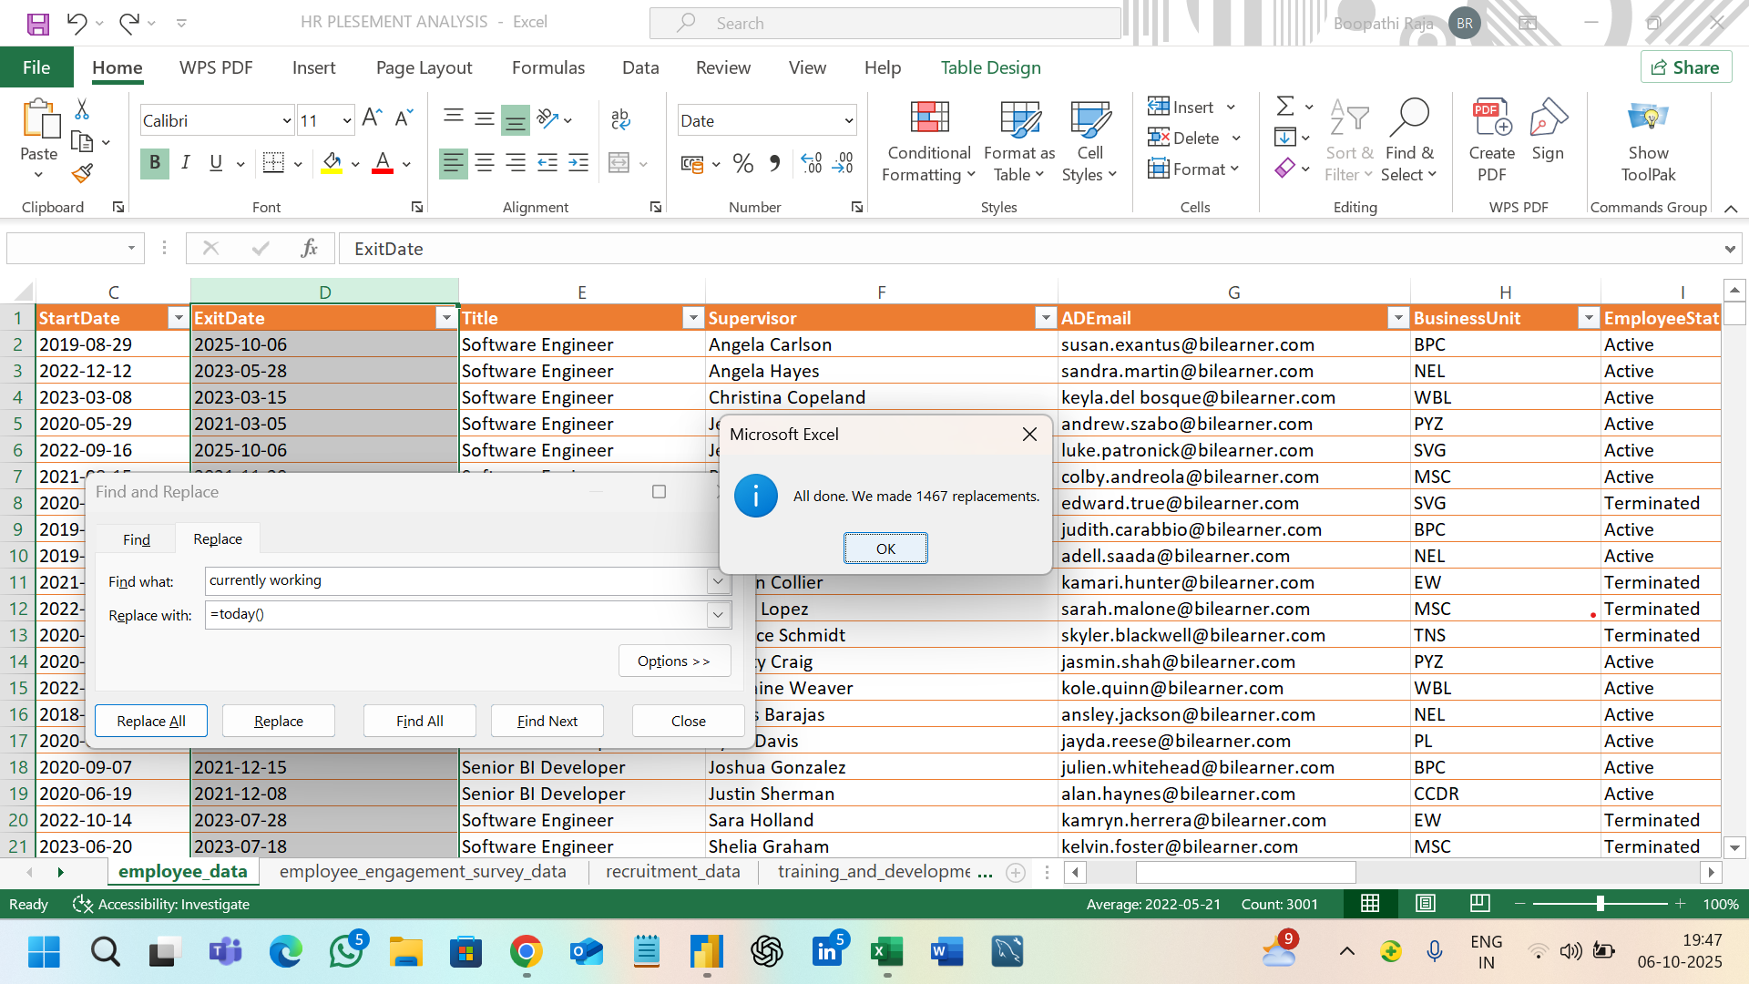

**Handle Null / Invalid Value:**

You can use the shortcut CTRL + F to open up the FIND menu. This allows you to input the data value you are looking for, and Excel will show you all occurrences of it in your worksheet.

If you press CTRL + H, this opens the FIND & REPLACE menu.

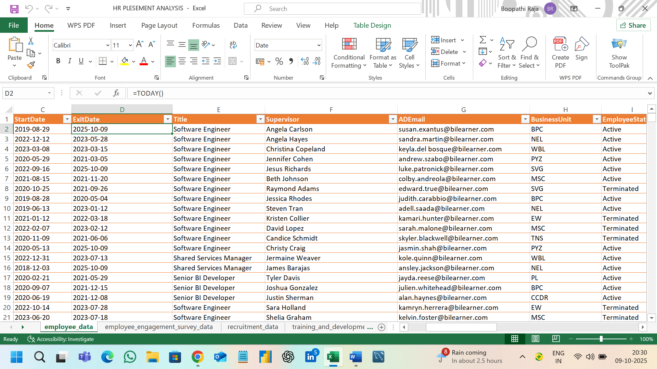

**Text Clean-up:**

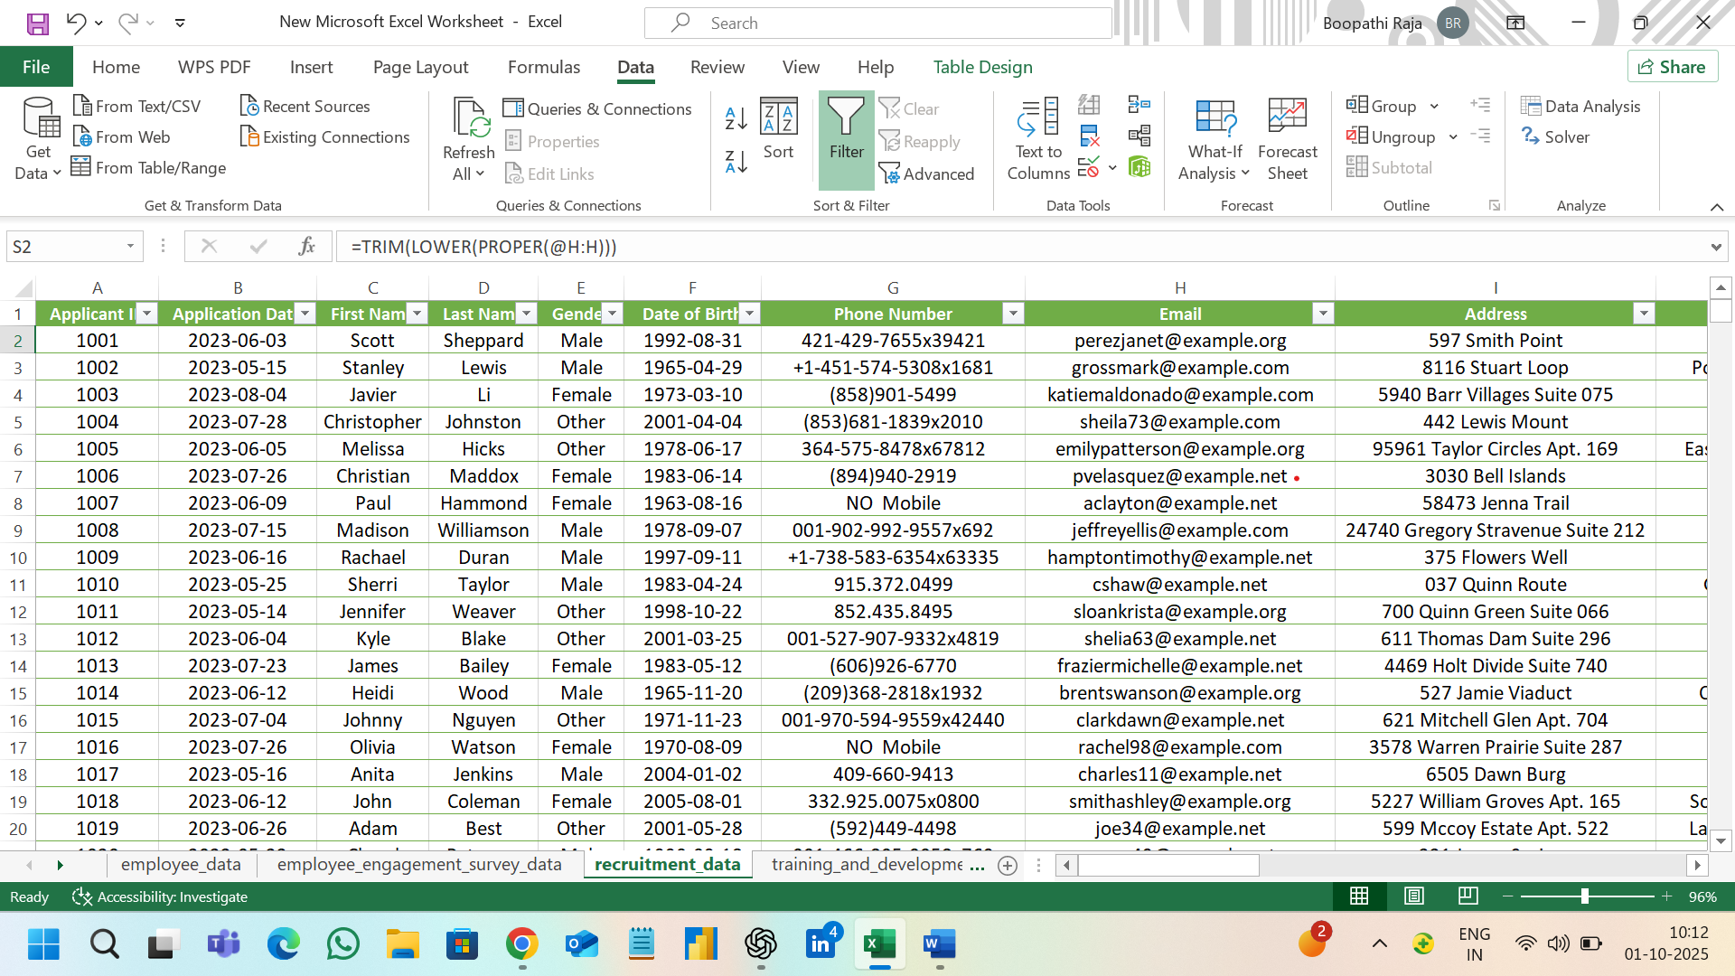

**Standardize Date & currency Columns:**

Standardize the date and columns to the proper format based on solve the feature of visualization process.

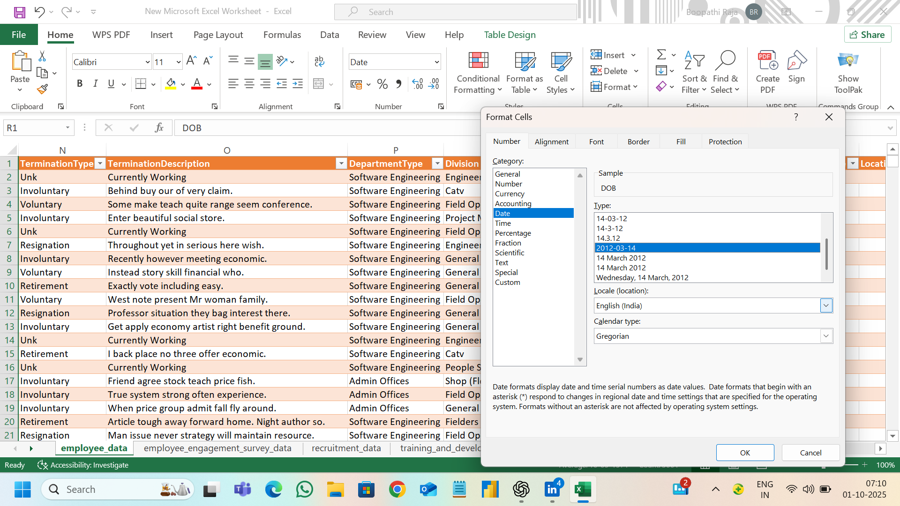

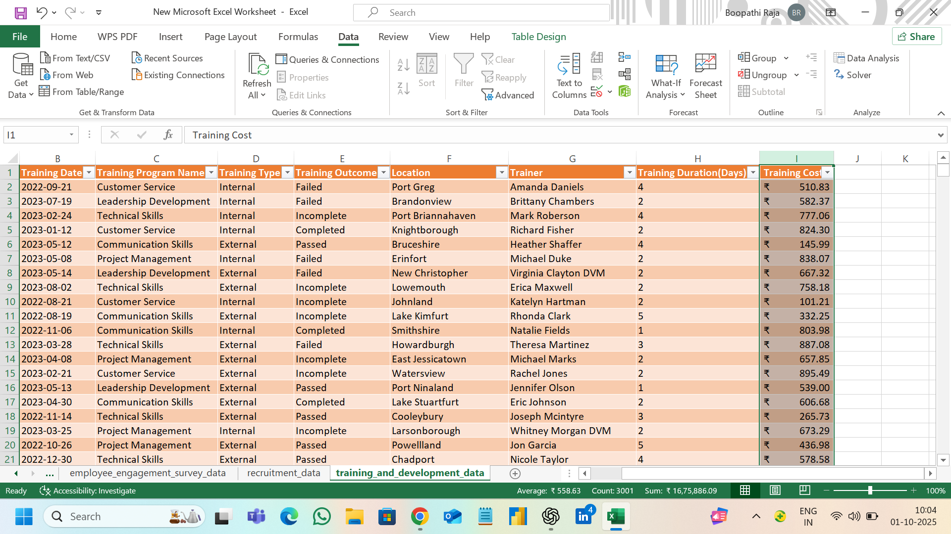

**DATA TRANSFORMATION:**

1. **Concatenate / Combine Columns:**

**= CONCAT (B2, C2) to join first name and last name**

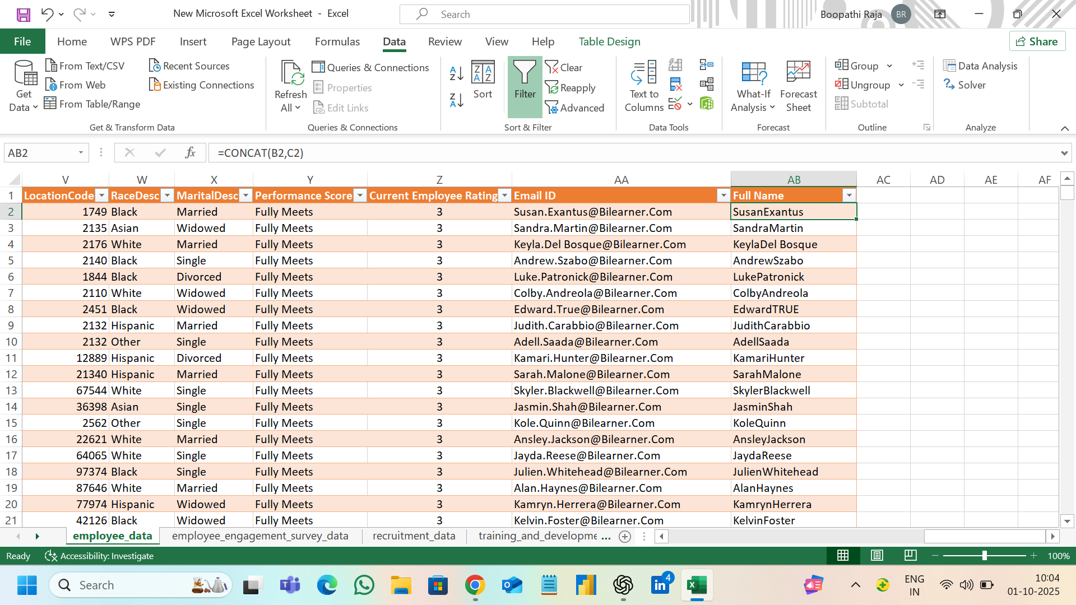

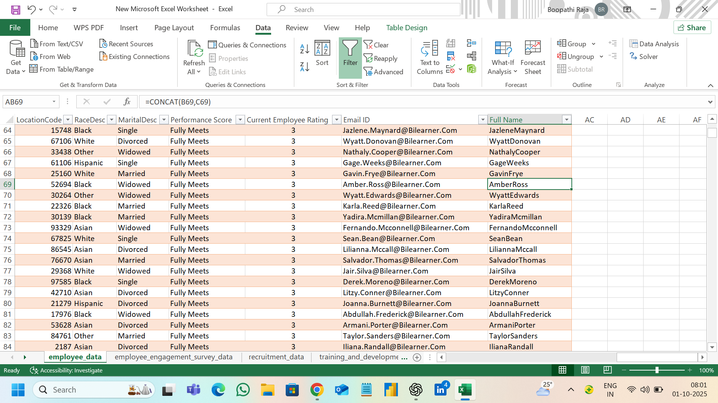

**FIND AGE:**

Find the age based on date of birth.

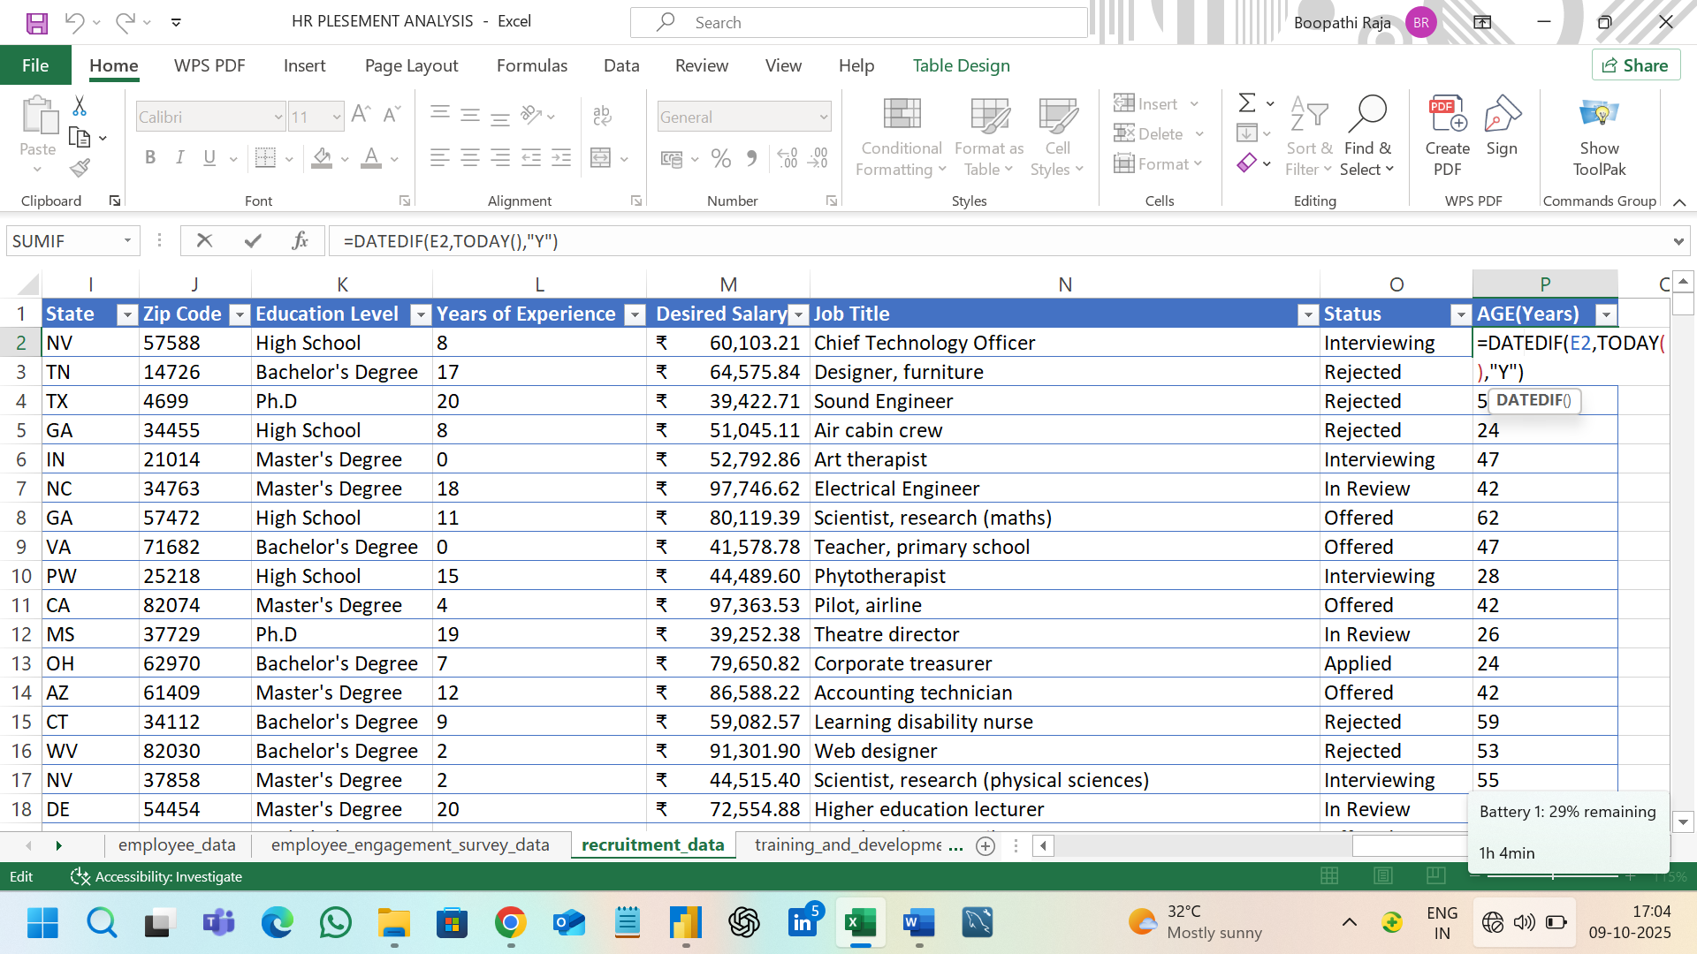

**FIND EXPERIENCE:**

Find the experience based on start date and last date.

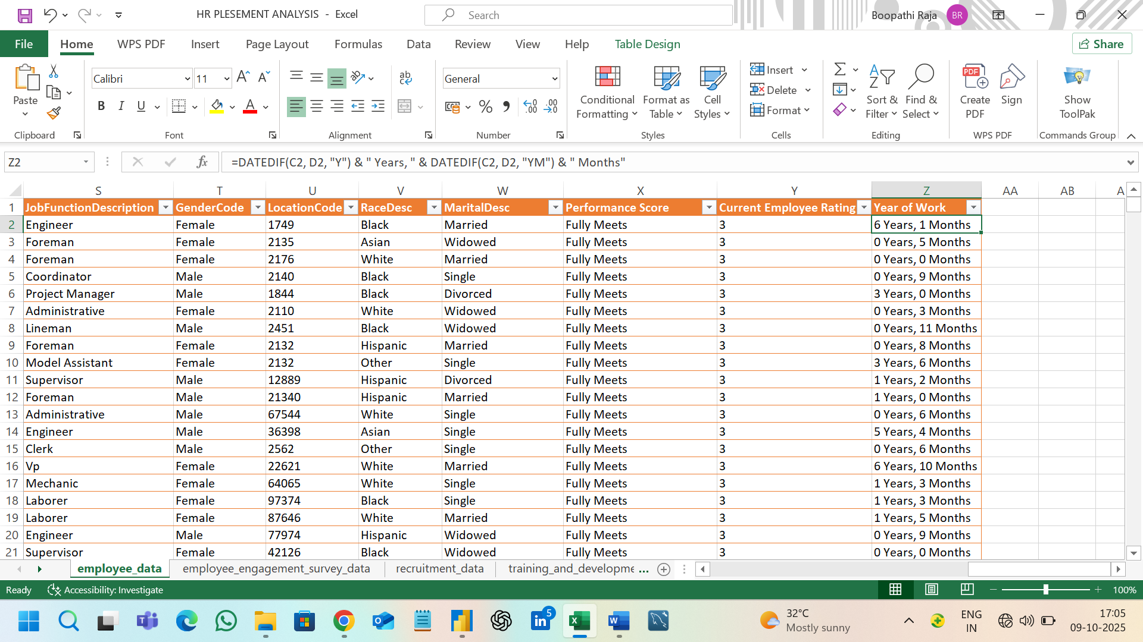

**CHANGE FULL NAME:**

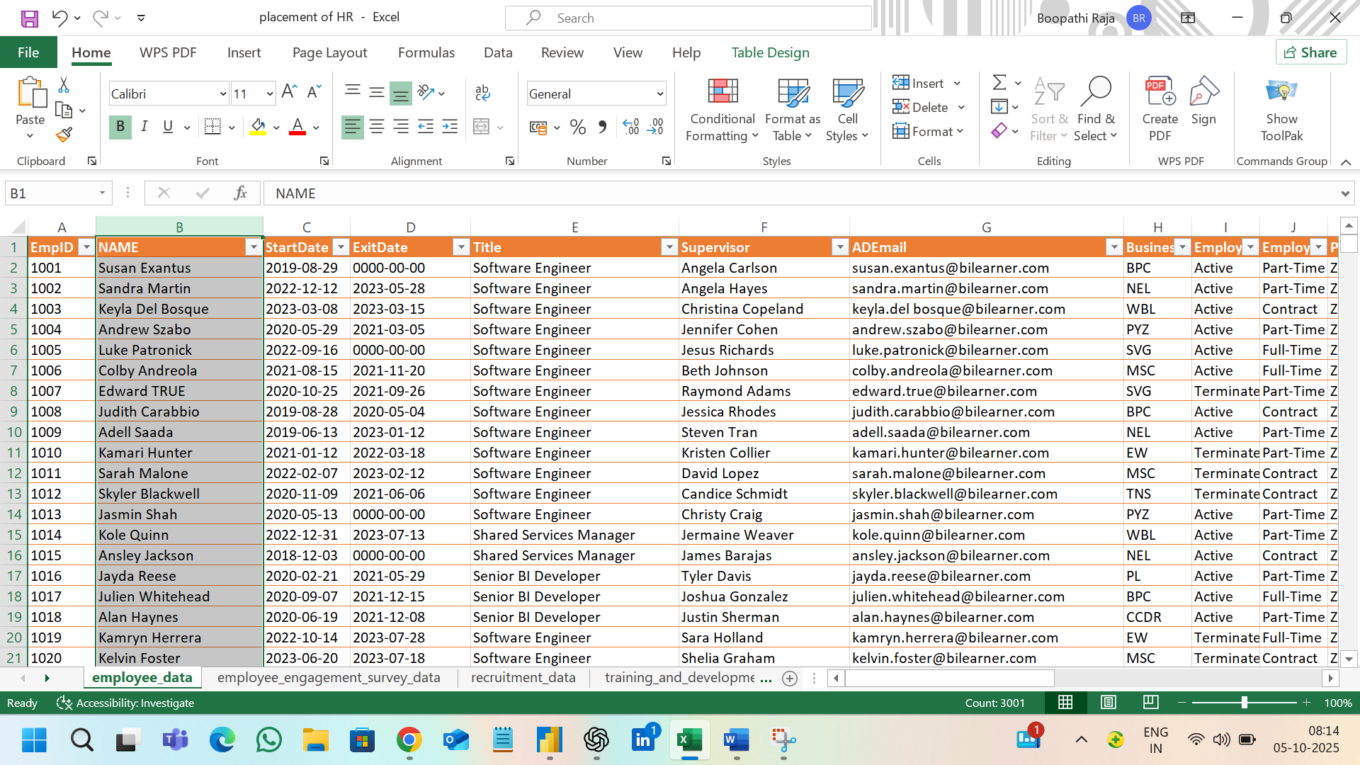

**Conditional Transformation:**

**Desire salary report to create the new column to high and low values.**

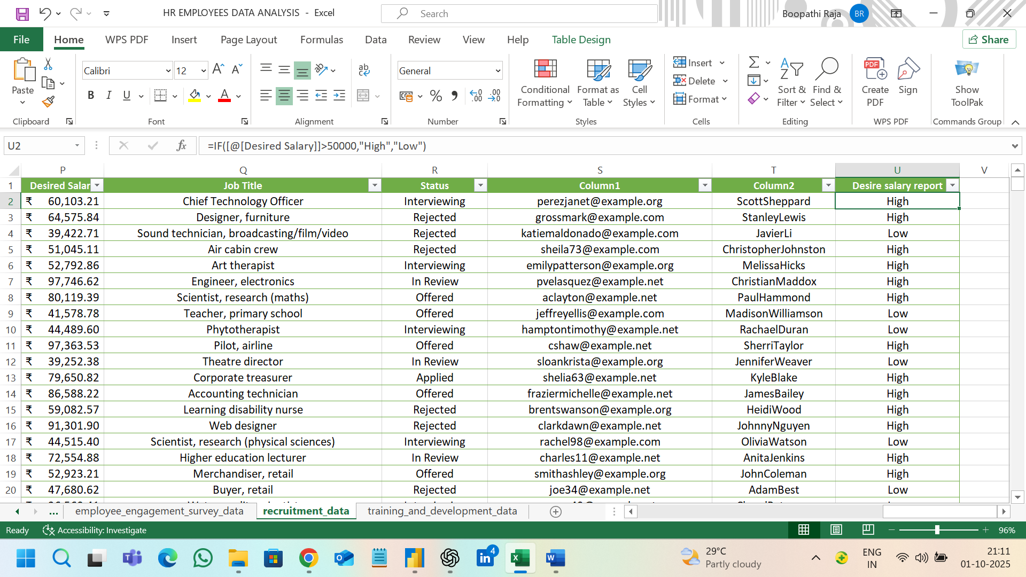

**PROPER CONDITION PHONE NUMBER AND ADDRESS:**

To create the new column to the address to connect the state and country columns.

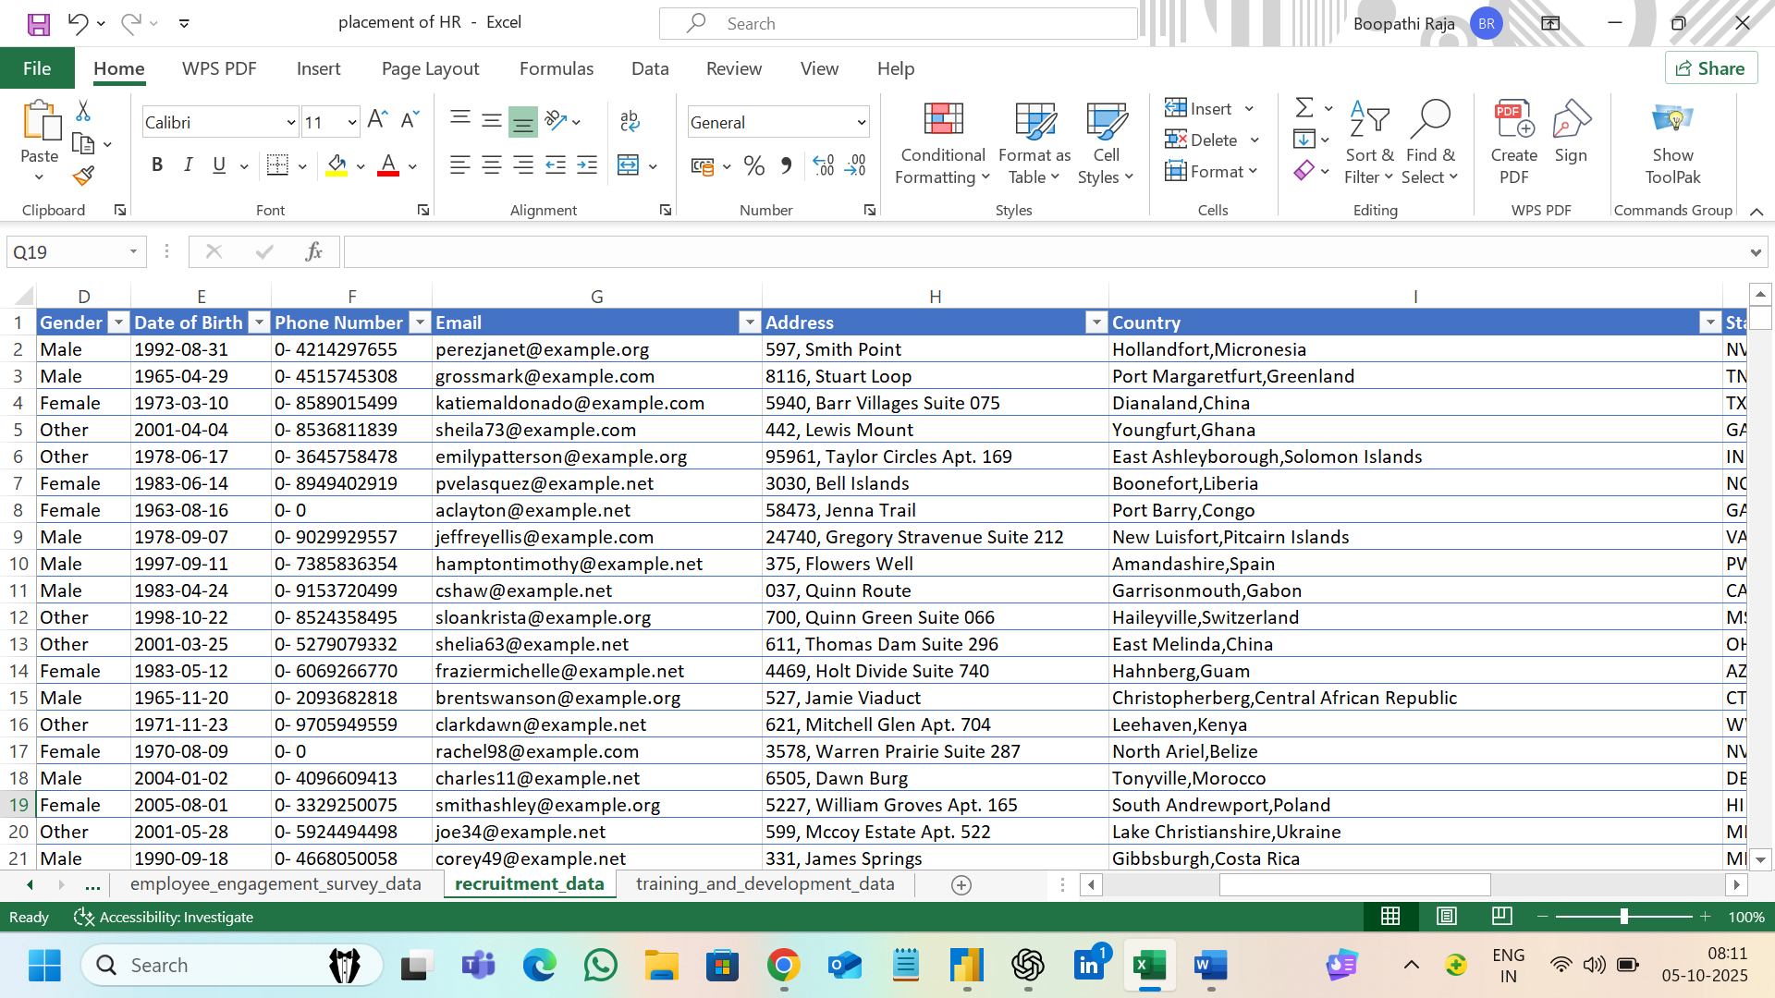

**Removed Unwanted Columns**:

To remove unwanted columns in particular sheets.

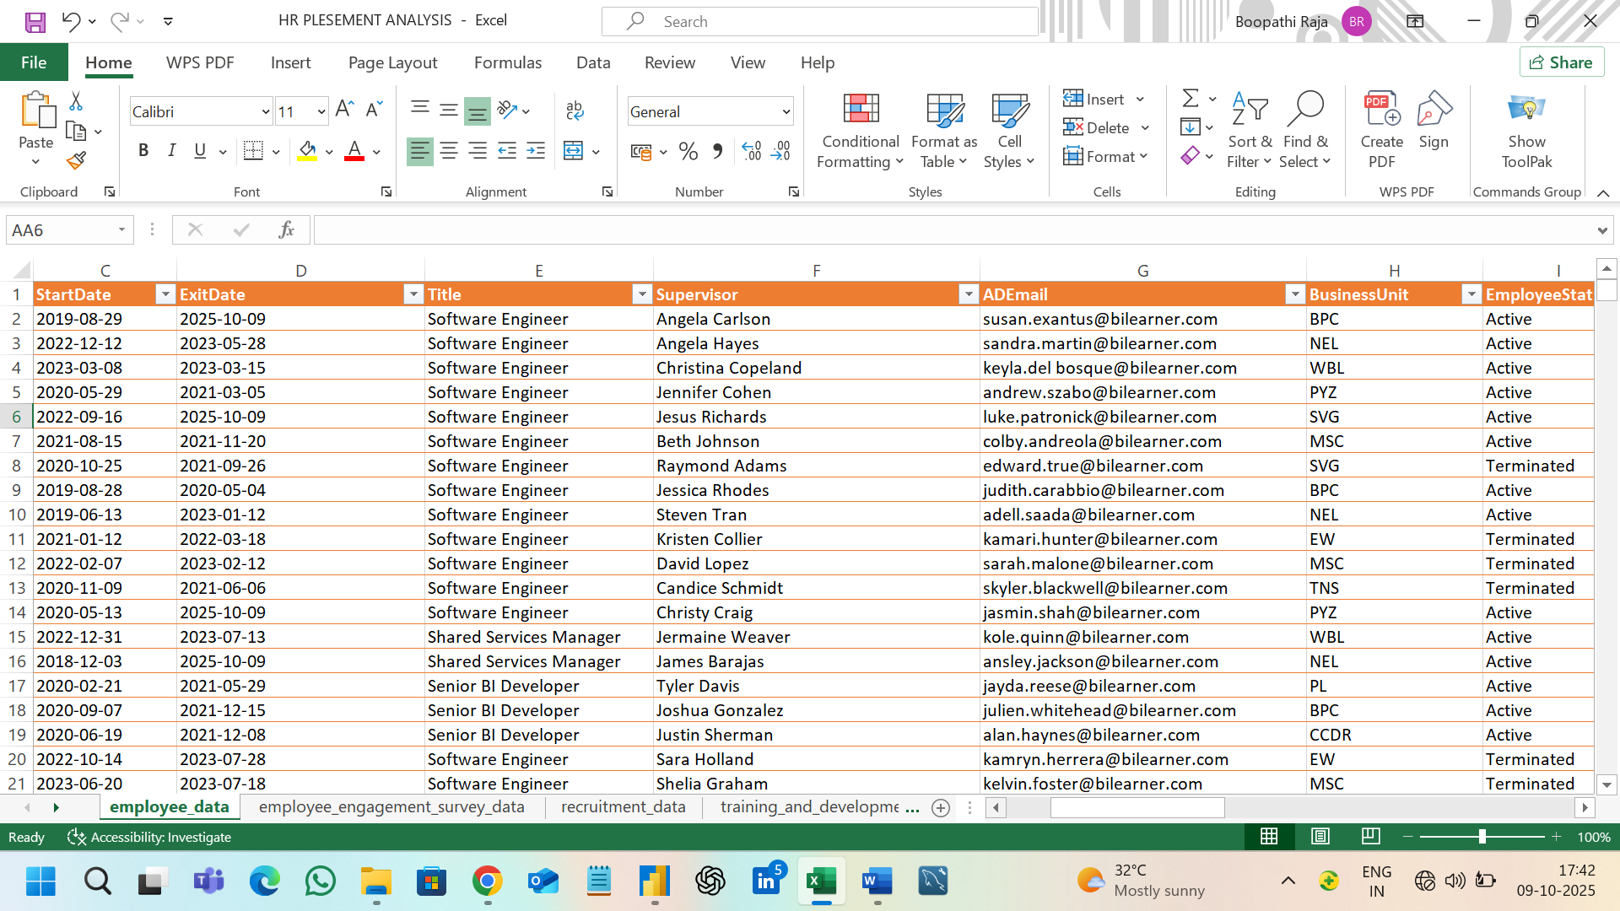

**MODELLING AND VISHUALIZAION IN POWER BI**

**MODELLING:**

Insert the excel format to power BI in modelling to create the visualization charts and add DAX formulas to Create a total final report.

**Find measures**:

Create the new measures in power bi data sheets.

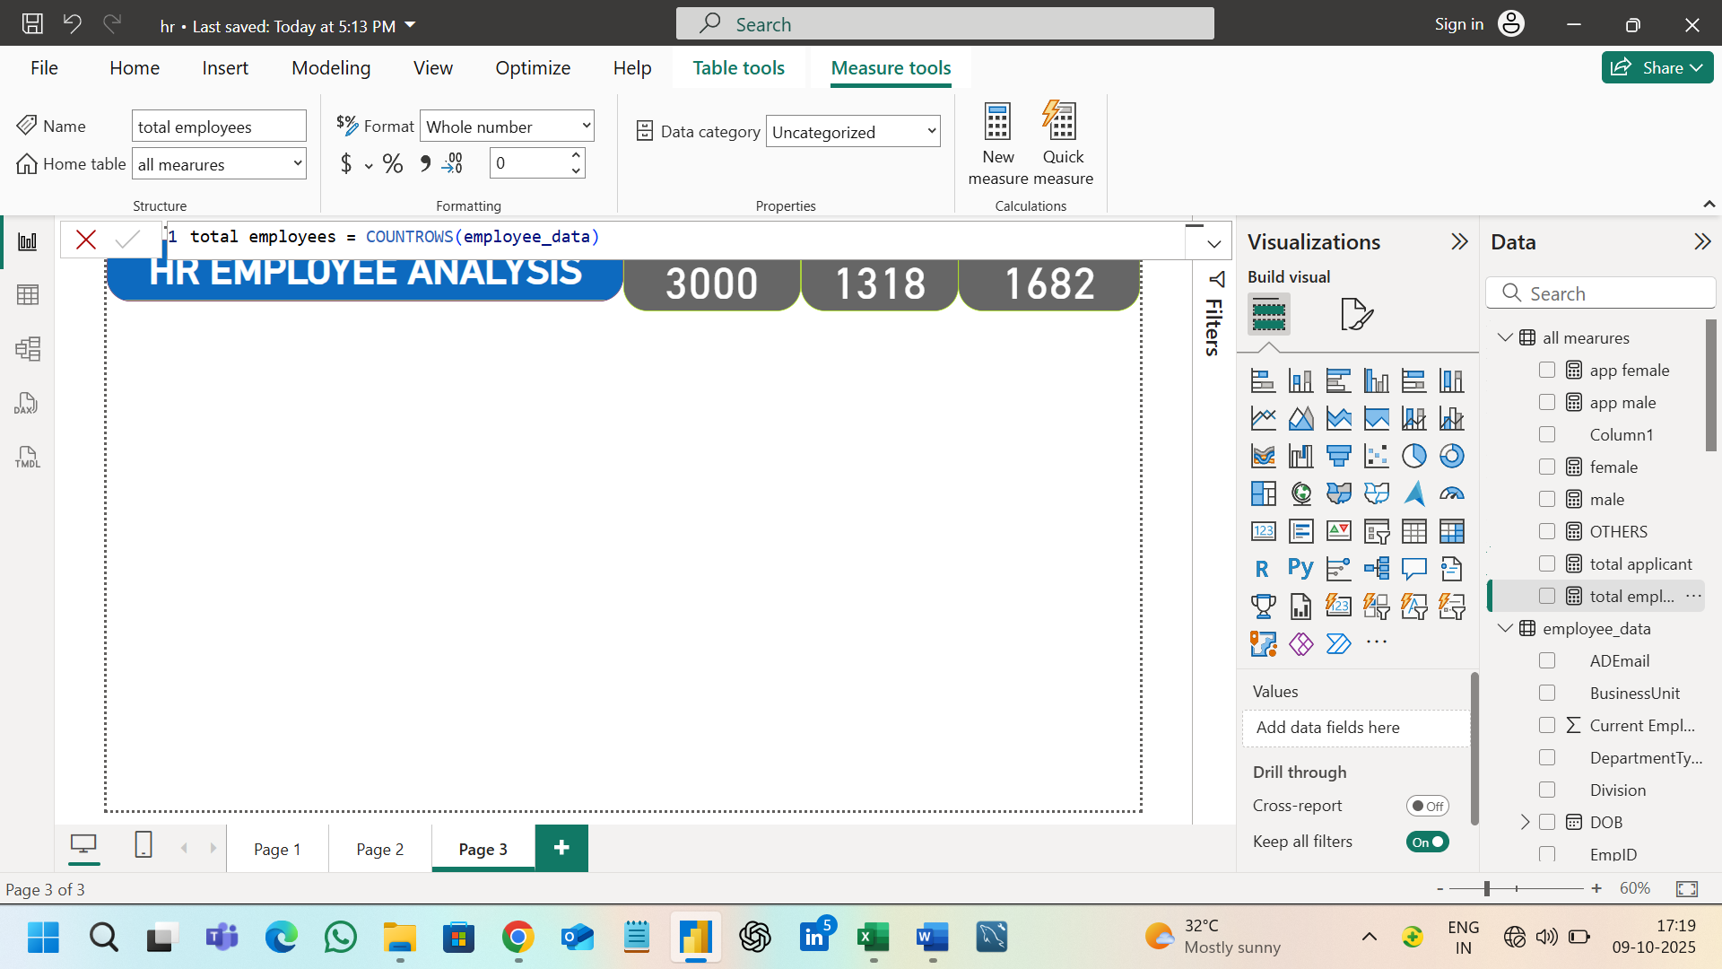

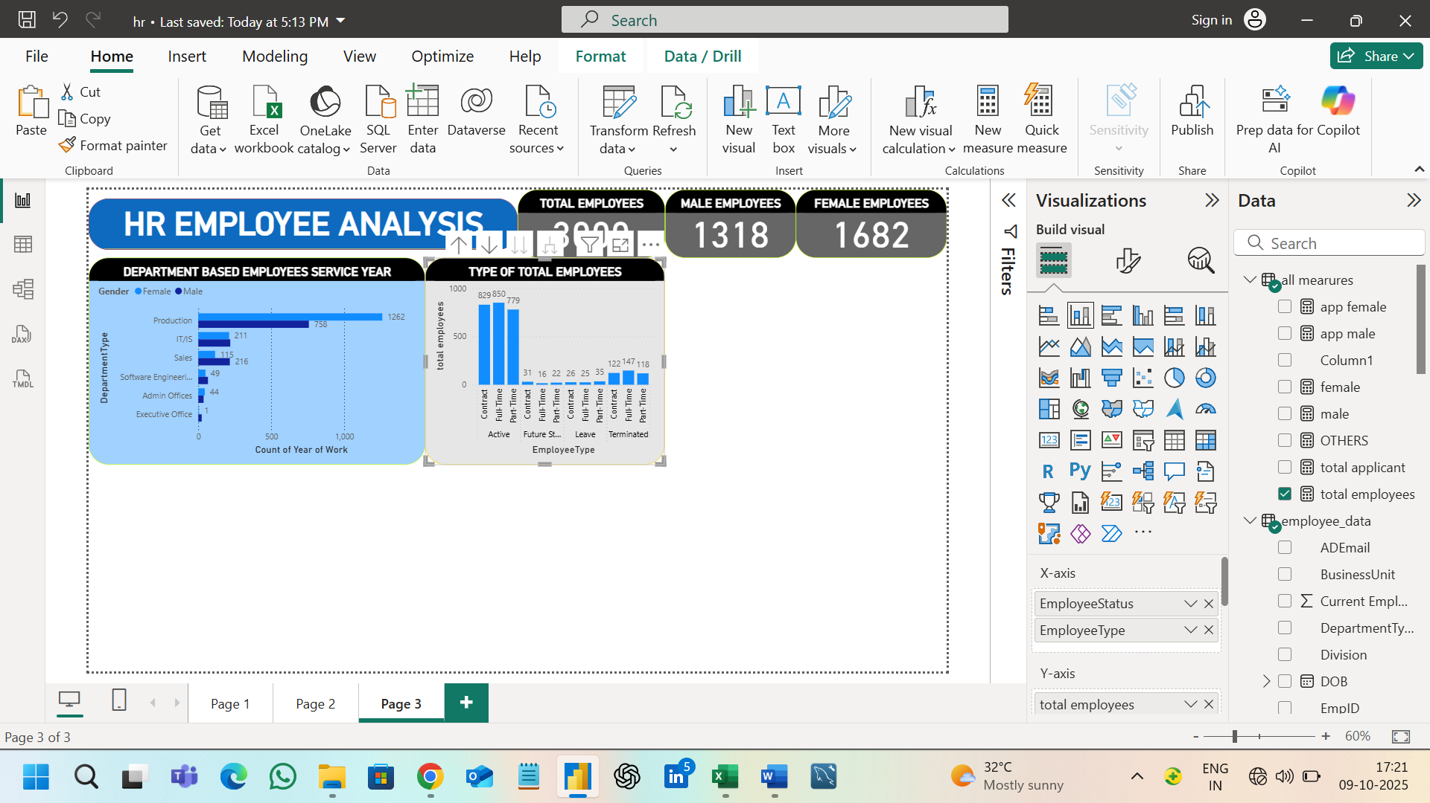

**Calculate Function**:

To Calculate the functions by based on visualizations process.

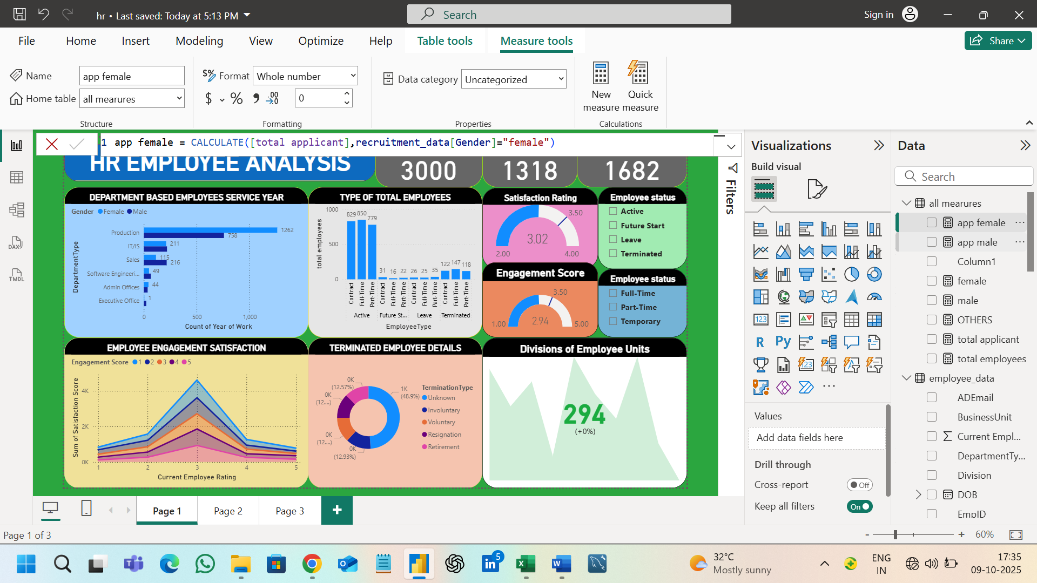

**Final Visualization view:**

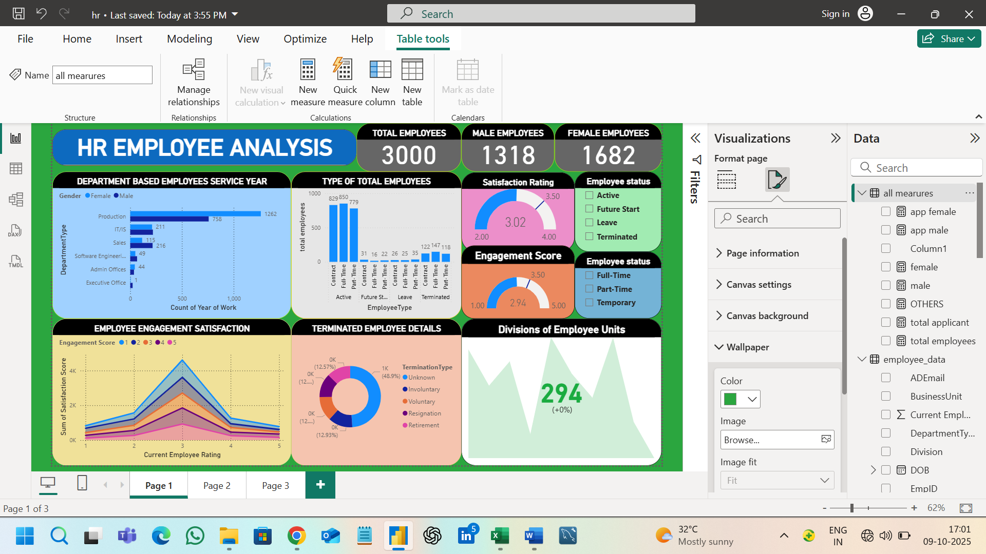

**Calculate Function**:

To Calculate the functions by based on visualizations process.

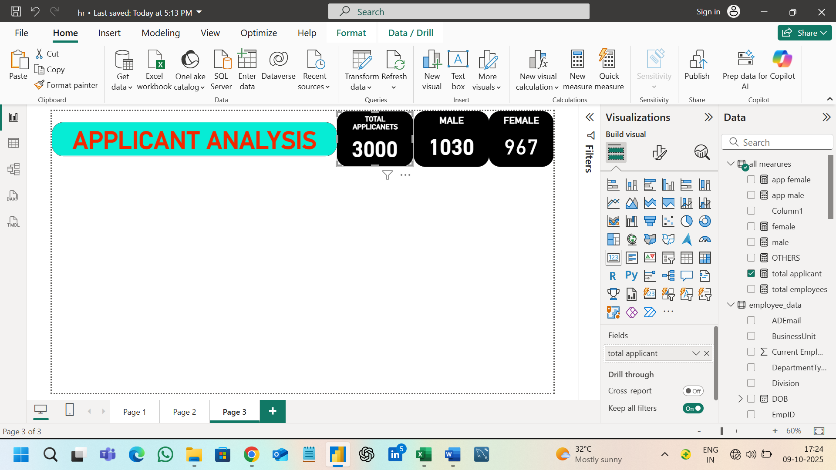

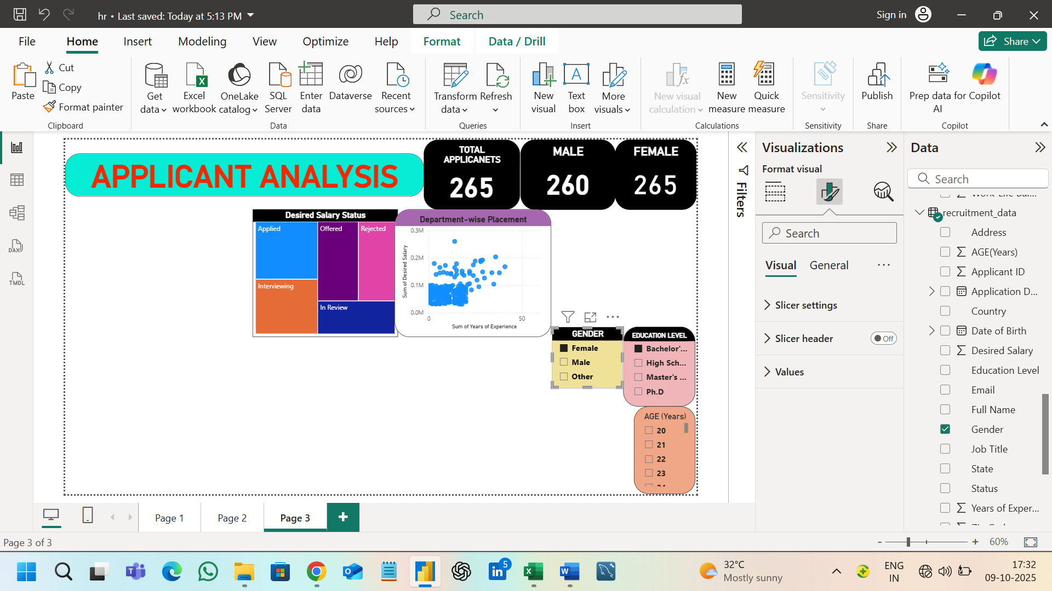

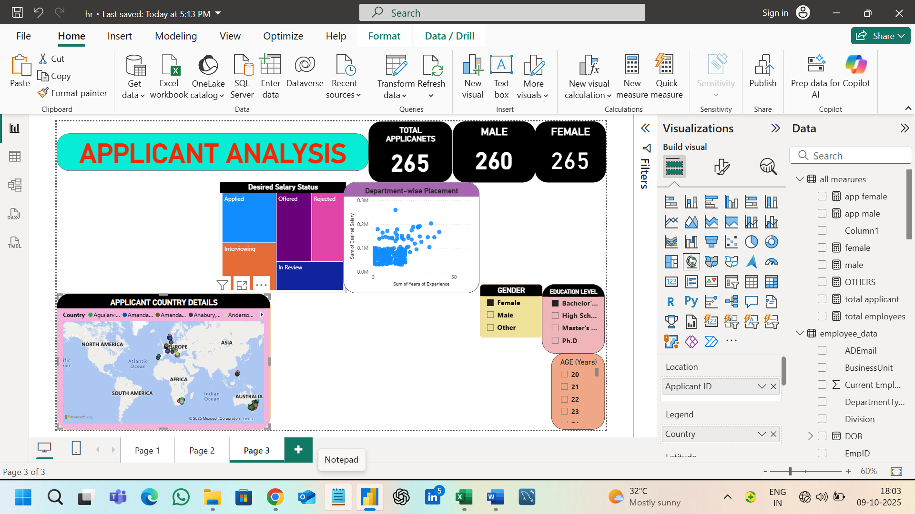

**Final view:**

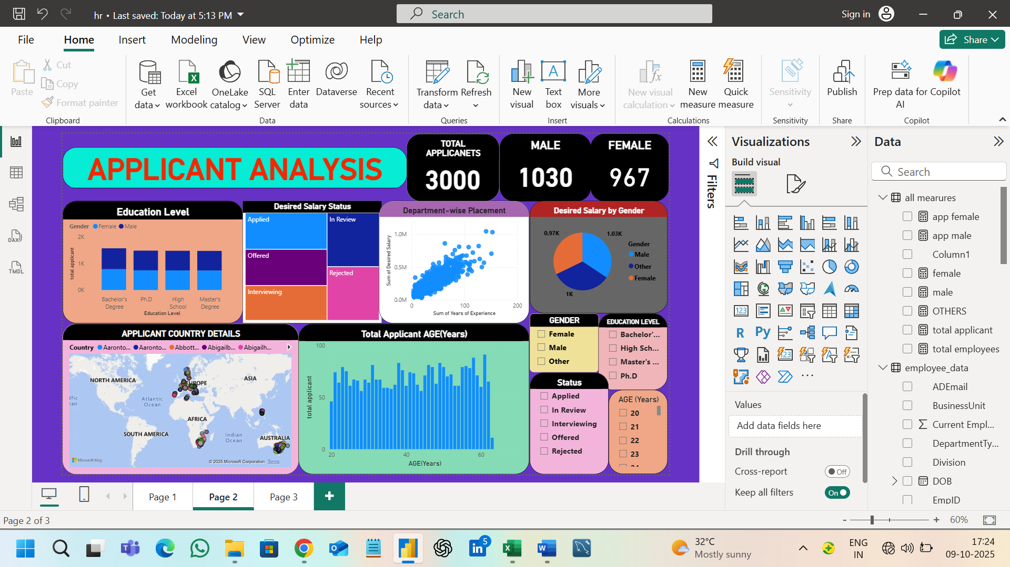

HR EMPLOYEE ANALYSIS DASHBOARD:



APPLICANT ANALYSIS DASHBOARD:

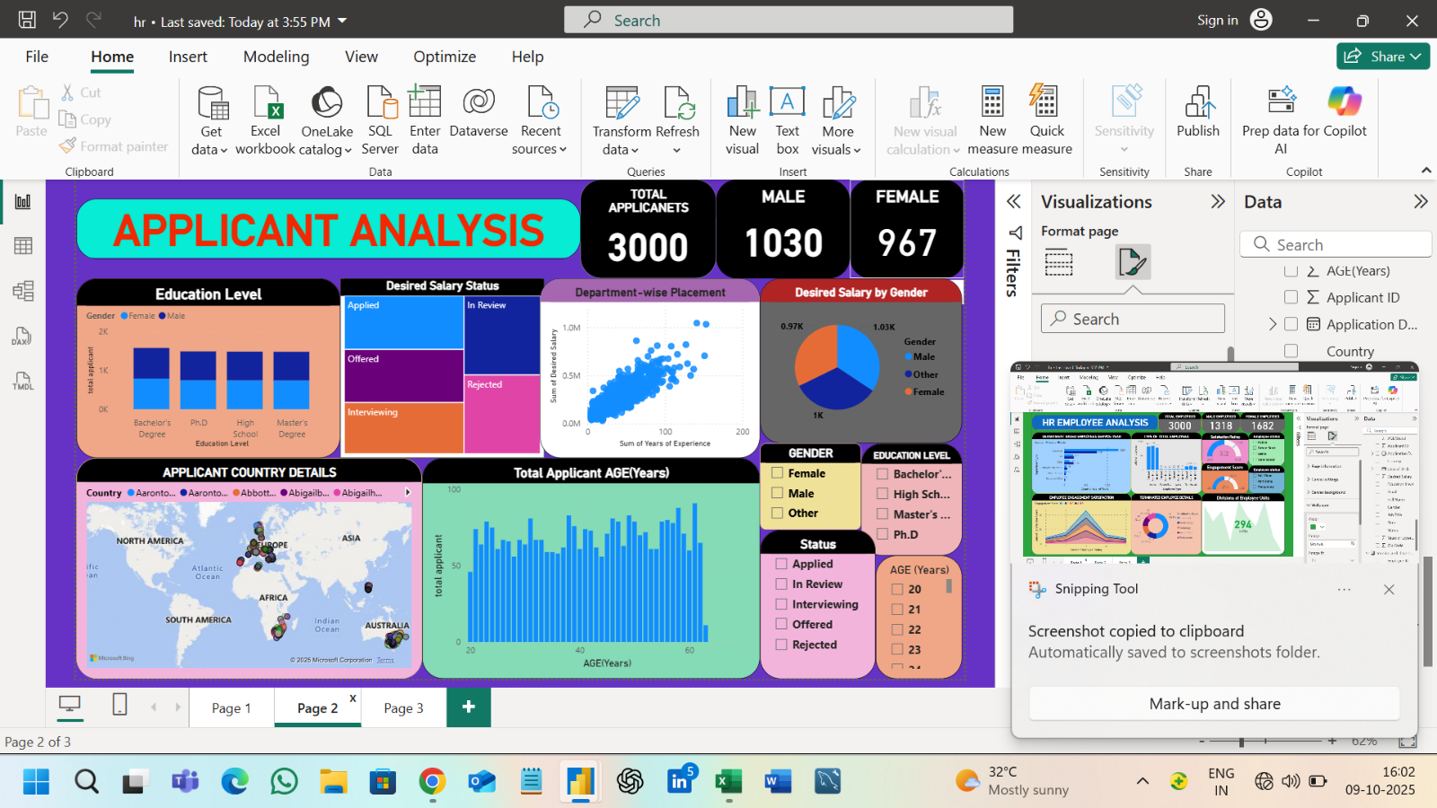

-----Thank you----